Full Paper MS Word Template

Full Paper MS Word Template for

Genome Informatics 2003

FirstName1 Middle Name LastName1¹ FirstName2 LastName2²
lastname1@disorder.chem.wsu.edu lastname2@jaist.ac.jp

FirstName3 LastName3³
lastname3@ims.u-tokyo.ac.jp

¹ School of Molecular Biosciences, Washington State University, Pullman, WA 99164,
U.S.A.
² Japan Advanced Institute of Science and Technology, 1-1 Asahidai,Tatsunokuchi,
Ishikawa 923-1292, Japan
³ HumanGenome Center, Institute of Medical Science, University of Tokyo,4-6-1
Shirokane-dai Minato-ku, Tokyo 108-8639, Japan

Abstract

This document is a MS Word template file for preparing a full paper. Please read the instructions
carefully and prepare your manuscript.

Keywords: aberrant splicing, database, point mutation, scanning model

1 Introduction

The page limit for full paper is TEN. In case the number of pages still exceeds this limit after your efforts, please contact the Editor-in-Chief (Satoru Miyano: giw@ims.u-tokyo.ac.jp) for advice.
Do not change the text width, text height, baseline, font size, etc., specified in this template file.

2 Method and Results

Of course you can create more sections with any section titles.

2.1 Tables

Table 1 is an example of a table.

Table 1: Bioinformatics conferences in 2003.
Conference Date Site
PSB January 3-7 Hawaii
RECOMB April 10-13 Berlin
ISMB August 3-7 Edmonton
GIW December 16-18 Tokyo
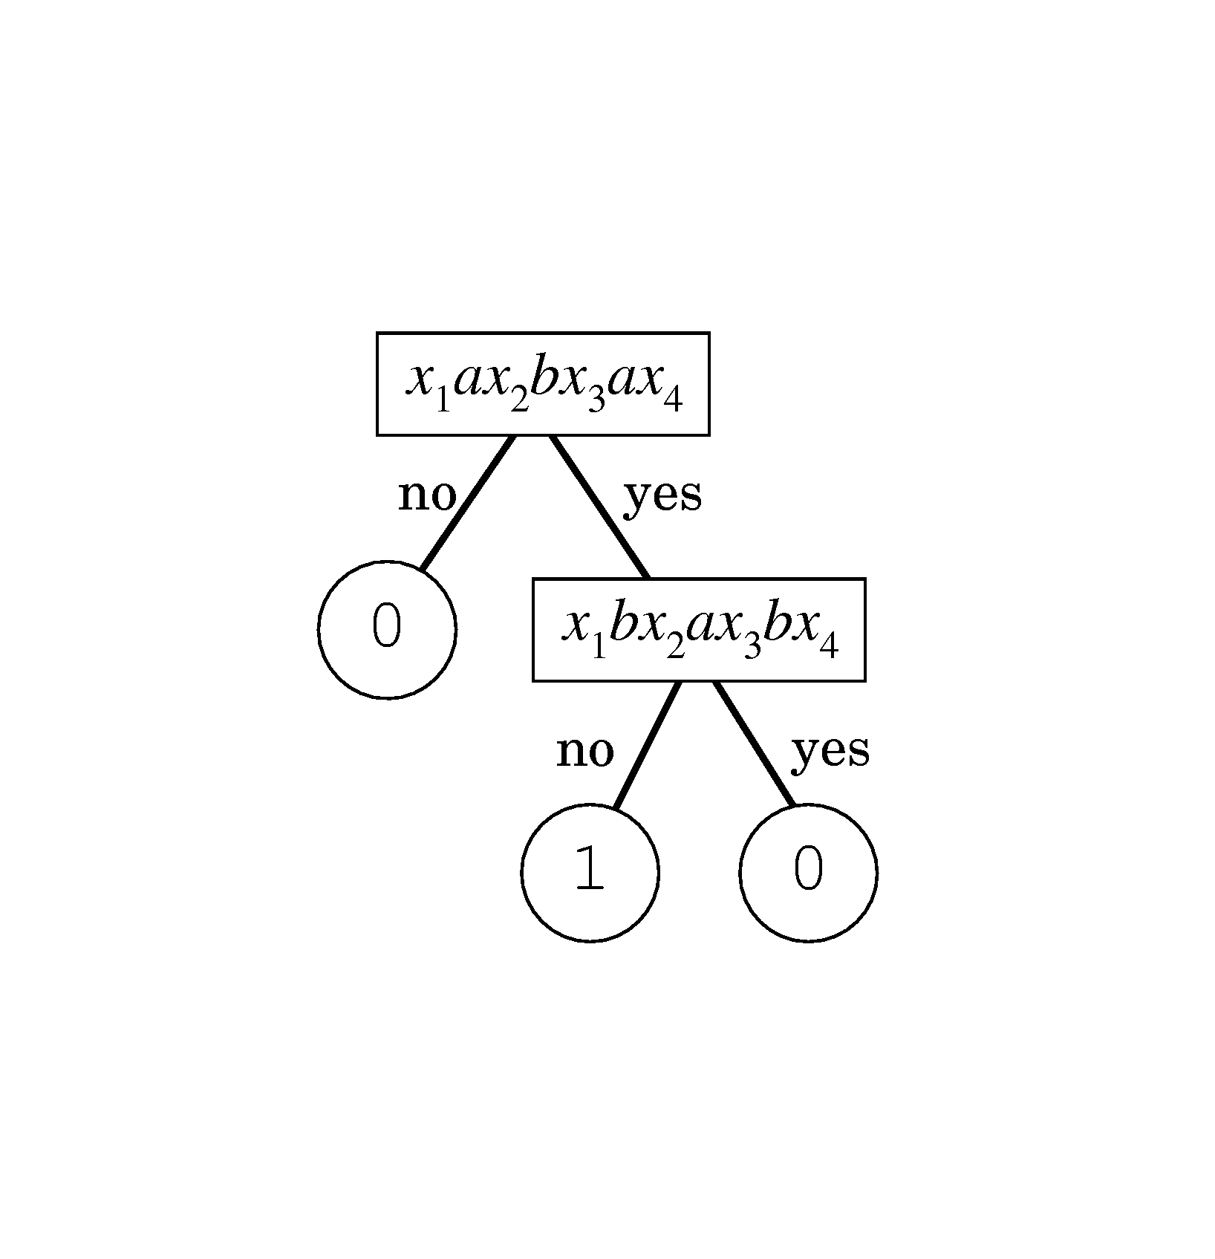

Figure 1: This is a sample figure. Figure 2: This is a color sample figure.

2.2 Figures.

Sample figures are given in Fig. 1 and Fig. 2.
Printed version of ``Genome Informatics'' is monochromatic and has a page limit. But, electronic version (PDF, then HTML, XML) does not have such restrictions. Therefore, we encourage the author(s) to send any hypermedia files which can be attached to your paper. The electronic version will be open to public at JSBi Home Page (http://www.jsbi.org/journal.html).

2.3 Citation and References

Here are examples of citation [1,2,3,4,5,6]. Reference style and citation should strictly follow this template.

- References should be arranged in the alphabetical order of authors and all references should be cited in the paper.

2. Style (see examples in References below).

  - Journal: author(s), title, journal name, vol(issue):startpage-endpage, year.
  - Proceedigns: author(s), title, Proc. conference name, publisher (if possible), startpage-endpage, year.
  - Book: author(s), title, publisher, year.
  - Other: author(s), title, any helpful information, year.
  - URL: http://(URL site). URLs should be listed in the last.

3 Discussions

Authors are recommended to use spell checker program and grammar check
program for improving your final version.

References

[1] Akutsu, T., Kuhara, S., Maruyama, O., and Miyano, S.Identification of gene regulatory networks by strategic gene disruptions and gene overexpressions, Proc. 9th ACM-SIAM Symp. Discrete Algorithms, 695-702, 1998.

Full Paper MS Word Template

[2] Chen, T., He, H.L., and Church, G.M., Modeling gene expression with differential equations, Proc. Pacific Symp. Biocomputing '99, World Scientific, 29-40, 1999.

[3] Doi, K. and Imai, H., A greedy algorithm for minimizing the number of primers in multiple PCR experiments, Genome Informatics, 10:73-82, 1999.

[4] Motowani, R. and Raghavan, P., Randomized Algorithms, Cambridge University Press, 1994.

[5] Smith, T.F. and Waterman, M.S., Identification of common molecular subsequences,
J. Mol. Biol., 147(1):195-197, 1981.

[6] http://www.jsbi.org/

